**Concept for Eleni’s logo**

**Team “Orange”**

We would like to share our concept for the logo of Eleni’s website. Our main goal was to represent Eleni’s personality and background through the logo.

***First Stage***

Our starting point was sticking to the requirements of Eleni: she wants to have a minimalistic and artistic logo (icon / symbol). Also, we considered the colors which she prefers (black, dark grey, orange and warm purple).

***Second Stage***

We wanted to create a logo which represents her background and culture. The first association which we made was her nationality and profession. So, our thinking process led us to a connection between Greek nationality and education. We developed the idea of analyzing the meaning behind the Greek alphabet. Why? Because the alphabet is the base which opens the doors to gaining knowledge.

Our research started with going deeper into how the letters looked as well as their meaning. One idea was to use the letter Σ (sigma), which symbolizes communication, which is in-line with the idea of homo-bradypous and what she wants - to bring back the lost connection between people. Another concept we had was for the letter H (Eta), which is composed of two I’s (iota) united. Since Ι describes the descent of a small quantity of force, light or radiation that constantly supplies… when this small quantity becomes greater, it becomes also visible. The final idea we settled on the letter λ (lambda). We found a quote from [Greek Porter website](https://greekreporter.com/2013/10/12/decoding-hidden-meanings-of-ancient-greek-alphabet-letters/#:~:text=According%20to%20the%20Greek%20Alphabet,continue%20to%20%E2%80%9Ccarry%E2%80%9D%20meanings) which caught our attention. *“When children draw the sun, they make a circle with rays”* *(Examples below):*

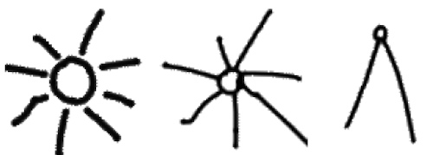

The letter that exactly expresses the Solar radiation, is **Λ**(Lambda), and it is defined so, by the Greek Alphabet Code, as **Λ** = Solar radiation and liquids in Nature (when referring to forces on Earth).” We really liked this idea because it includes many great details that relate to Eleni’s life and profession: children draw the sun with lambda – this represents Eleni’s target audience, sun – indicates Eleni’s knowledge which she spreads and uses to inspire others.

We also looked at Eleni’s name interpretation in the Greek culture. It translates as “Sun rays” which is a perfect fit for our logo concept.

***Third stage***

As a result, we concluded two final ideas for a logo, and we would be happy to discuss it with our client Eleni.

**Idea #1**

The style of the drawing will be that of a crudely drawn sun. *(Example below):*

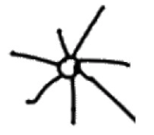

**Idea #2**

Make a digital option of the sun, print it and ask kids to fill it with colorful pencils. (preferably the students you teach)

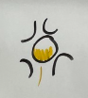

**Our sketches:**

